FULL STACK WEB DEVELOPMENT
LABORATORY RECORD — EXPERIMENT 04

1. BASIC INFORMATION
Experiment No. | 03
Date | 14/08/2026
Title | Dynamic Webpage using JavaScript DOM
Application | Dynamic Webpage
Course Outcome | CO1

2. AIM
To develop a dynamic webpage using JavaScript and DOM manipulation, where webpage content can be changed dynamically through user interaction.

3. OBJECTIVES
- Select HTML elements using DOM methods.
- Read user input from form controls.
- Handle button click events using event listeners.
- Create and modify webpage elements dynamically.
- Display updated content without reloading the webpage.

4. THEORY
The Document Object Model (DOM) represents an HTML document as a tree of objects. JavaScript can access these objects and change their content, style, and structure while the page is running.
Event listeners allow JavaScript to respond to user actions such as button clicks. In this experiment, the input is read from the webpage and the result is dynamically inserted into the page.

5. SOFTWARE / APPARATUS USED
- Computer / Laptop
- Windows 10 / 11
- Visual Studio Code
- Google Chrome / Microsoft Edge
- HTML5, CSS3 and JavaScript

6. ALGORITHM / PROCEDURE
- Create an HTML page with a heading, input field, button and output area.
- Style the page using CSS.
- Select the required HTML elements using getElementById().
- Attach a click event listener to the button.
- Read the value entered by the user.
- Create or modify DOM elements using JavaScript.
- Display the generated content in the output area.
- Run the page in a browser and verify the dynamic output.

7. SOURCE CODE

HTML — index.html
<!DOCTYPE html>
<html>
<head>
<title>Dynamic Webpage</title>
<link rel="stylesheet" href="style.css">
</head>
<body>
<div class="container">
<h1>Dynamic Webpage</h1>
<input type="text" id="name" placeholder="Enter your name">
<button id="showBtn">Show Message</button>
<div id="output"></div>
</div>
<script src="app.js"></script>
</body>
</html>

JavaScript — app.js
const button = document.getElementById("showBtn");
button.addEventListener("click", function () {
const name = document.getElementById("name").value;
const output = document.getElementById("output");
if (name.trim() === "") {
output.textContent = "Please enter your name.";
return;
}
output.textContent = "Welcome, " + name + "!";
});

CSS — style.css
body {
font-family: Arial, sans-serif;
background: #f2f2f2;
padding: 40px;
}
.container {
width: 450px;
margin: auto;
padding: 30px;
background: white;
border-radius: 10px;
text-align: center;
}
input {
padding: 10px;
width: 60%;
}
button {
padding: 10px 18px;
margin-left: 5px;
cursor: pointer;
}
#output {
margin-top: 25px;
font-size: 20px;
font-weight: bold;
}

8. CODE EXPLANATION
Code / Concept | Purpose
getElementById() | Selects an HTML element by its ID.
addEventListener() | Responds to the button click.
value | Reads the value entered in the input field.
textContent | Changes the text displayed on the webpage.
trim() | Checks whether the input contains meaningful text.
DOM manipulation | Changes webpage content without reloading.

9. TEST CASES
Test Case | Input | Expected Result | Status
TC-01 | Sai Shishir | Welcome, Sai Shishir! | Pass
TC-02 | Any valid name | Welcome message is displayed | Pass
TC-03 | Empty input | Please enter your name. | Pass

10. EXECUTION STEPS
- Open the Experiment-04-Dynamic-Webpage/src folder.
- Open index.html in a browser.
- Enter a name in the input field.
- Click Show Message.
- Observe the dynamically generated message.
- Repeat with another name to verify that the content changes.

11. OUTPUT
The following is the actual captured browser output of the Dynamic Webpage experiment.
Figure 1: Dynamic Webpage — Actual Output
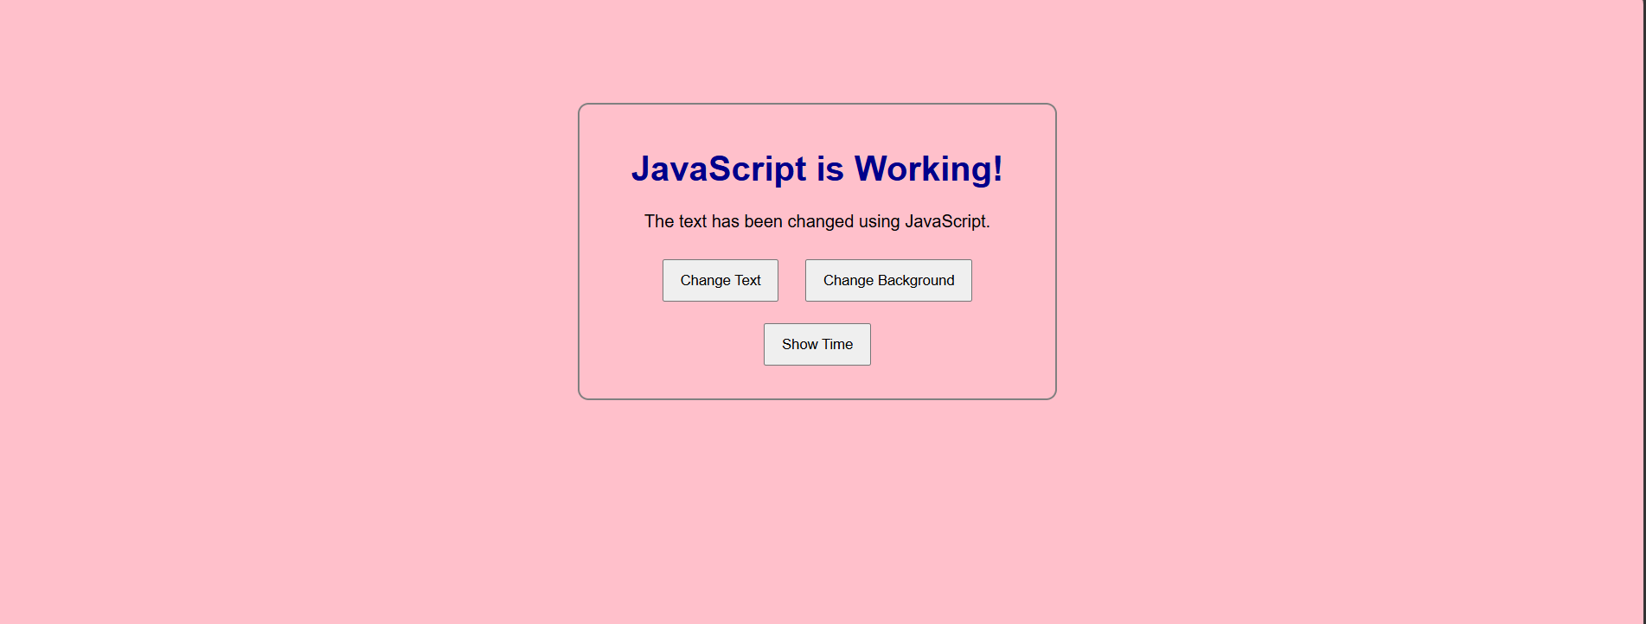

12. RESULT / CONCLUSION
The Dynamic Webpage was successfully implemented using JavaScript DOM manipulation and event listeners. User input was read and the webpage content was updated dynamically without reloading the page.

13. PRECAUTIONS
- Use matching IDs in HTML and JavaScript.
- Save all files before execution.
- Check that app.js and style.css are linked correctly.
- Test both valid and empty input.

14. VIVA-VOCE QUESTIONS
1. What is DOM?
DOM is the object representation of an HTML document.
2. What is an event listener?
It runs a function when a specified event occurs.
3. What is textContent used for?
It changes or reads the text content of an element.
4. Why is trim() used?
It removes extra whitespace and helps detect empty input.

